STOCKBRIDGE
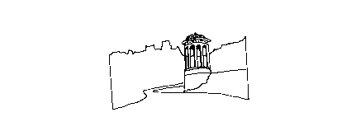
HEALTH CENTRE

GREEN PRACTICE
1 India Place, Edinburgh, EH3 6EH
Dr JA McLAREN Dr EF NICOL Dr J SAYERS Dr M REID Dr JP RICHARDS Dr S MARTIN
Tel: APPOINTMENTS 260 9226 ALL OTHER CALLS 260 9227
www.greenpractice-shc.co.uk

Dear Patient

Retirement

I will be retiring on March 31st 2010 after 25 years in the practice.

Throughout this time I have greatly enjoyed working with the Green Practice team to help ensure the highest standard of NHS care for you. I know that the team will continue to work hard to do this.

While I am sorry to cause further disruption at a time of change in the practice I am confident that the new partners and team will continue to develop and provide you with excellent care.

I wish you all the very best in the future

Yours sincerely

Dr Fiona Nicol

